Scilab Practical-1 Laplace Transform

Sample Question

**Ques**: .Draw the surface plot of Laplace Transfrom of following function keeping s=σ+j ω

**Code:**

$$f\left(t\right)=\left\{\begin{aligned}\sin{(4t+3)} , 0< &t<5 \\ 0 , 5< &t\end{aligned}\right.$$

clear; clc;

t=0:0.01:5; // function is defined in this range//

f=sin((4*t)+3);

a=1; //variable chosen to define the loop for sigma //

for sigma=-0.5:0.01:0.5, //range for sigma is required to plot the graph, format is initial value:increament:final value//

b=1; //variable chosen to define the loop for omega //

for omega =-0.5:0.01:0.5,

fr=f.*exp(-sigma*t).*cos(omega*t); //real part of integrand $e^{-st}f\left(t\right)=e^{-\left(σ+j ω\right)t}f(t)$//

ir(a,b)=inttrap(t,fr); //command to find integration of real part of integrand using trapezoidal rule//

fi=f.*exp(-sigma*t).*sin(omega*t);

li(a,b)=inttrap (t,fi);

magnitude (a,b)=abs(ir(a,b)+%i*li(a,b)); //evaluation of integral including real and imaginary part//

b=b+1; end;

a=a+1; end;

sigma=-0.5:0.01:0.5;

omega=-0.5:0.01:0.5;

plot3d(sigma,omega,magnitude) // plot3d is to be used to plot 3 variables and plot2d to plot 2 variables //

Dear All,

You have to upload the file in the following manner. Name the file as

batch_P1_roll no_first name

**Name**

**Batch and Roll no**

**Ques 1** Draw the surface plot of Laplace Transfrom of following function keeping s=σ+j ω

$$f\left(t\right)=\left\{\begin{aligned}\sin{(4t+3)} , 0< &t<5 \\ 0 , 5< &t\end{aligned}\right.$$

**Output:**

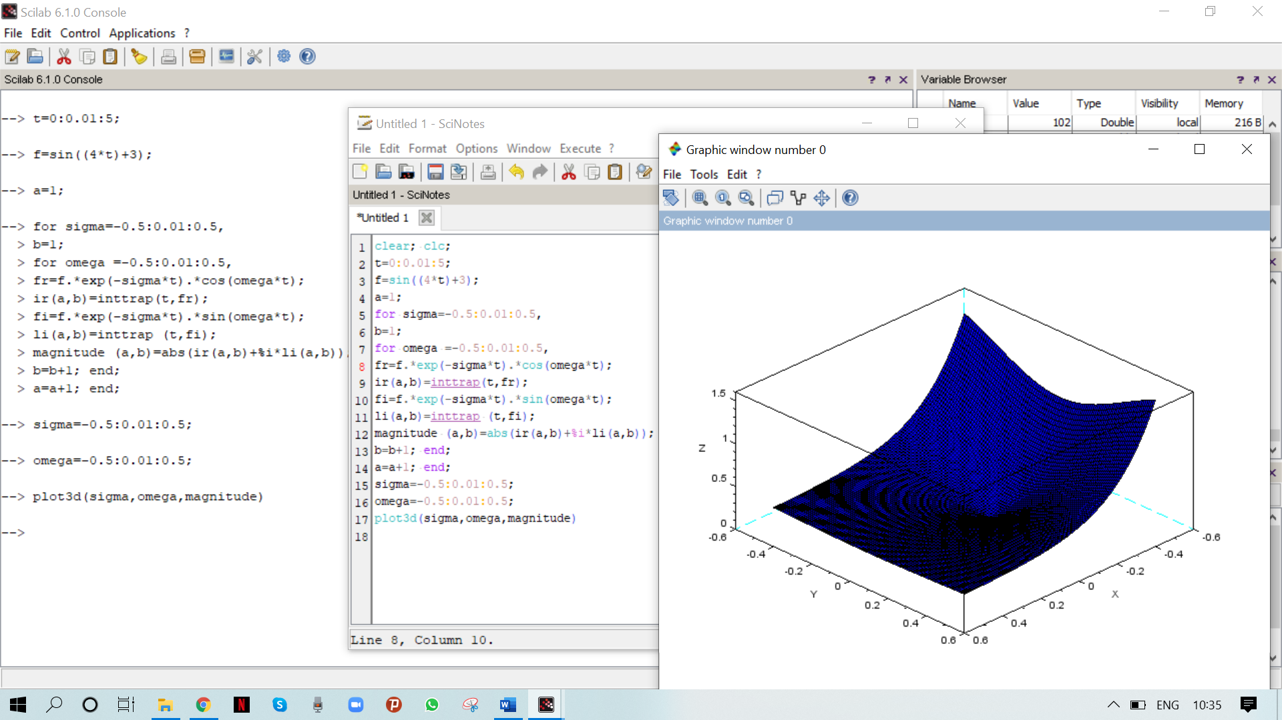

**Code on Scinotes**

clear; clc;

t=0:0.01:5;

f=sin((4*t)+3);

a=1;

for sigma=-0.5:0.01:0.5,

b=1;

for omega =-0.5:0.01:0.5,

fr=f.*exp(-sigma*t).*cos(omega*t);

ir(a,b)=inttrap(t,fr);

fi=f.*exp(-sigma*t).*sin(omega*t);

li(a,b)=inttrap (t,fi);

magnitude (a,b)=abs(ir(a,b)+%i*li(a,b));

b=b+1; end;

a=a+1; end;

sigma=-0.5:0.01:0.5;

omega=-0.5:0.01:0.5;

plot3d(sigma,omega,magnitude)

**Console Window**

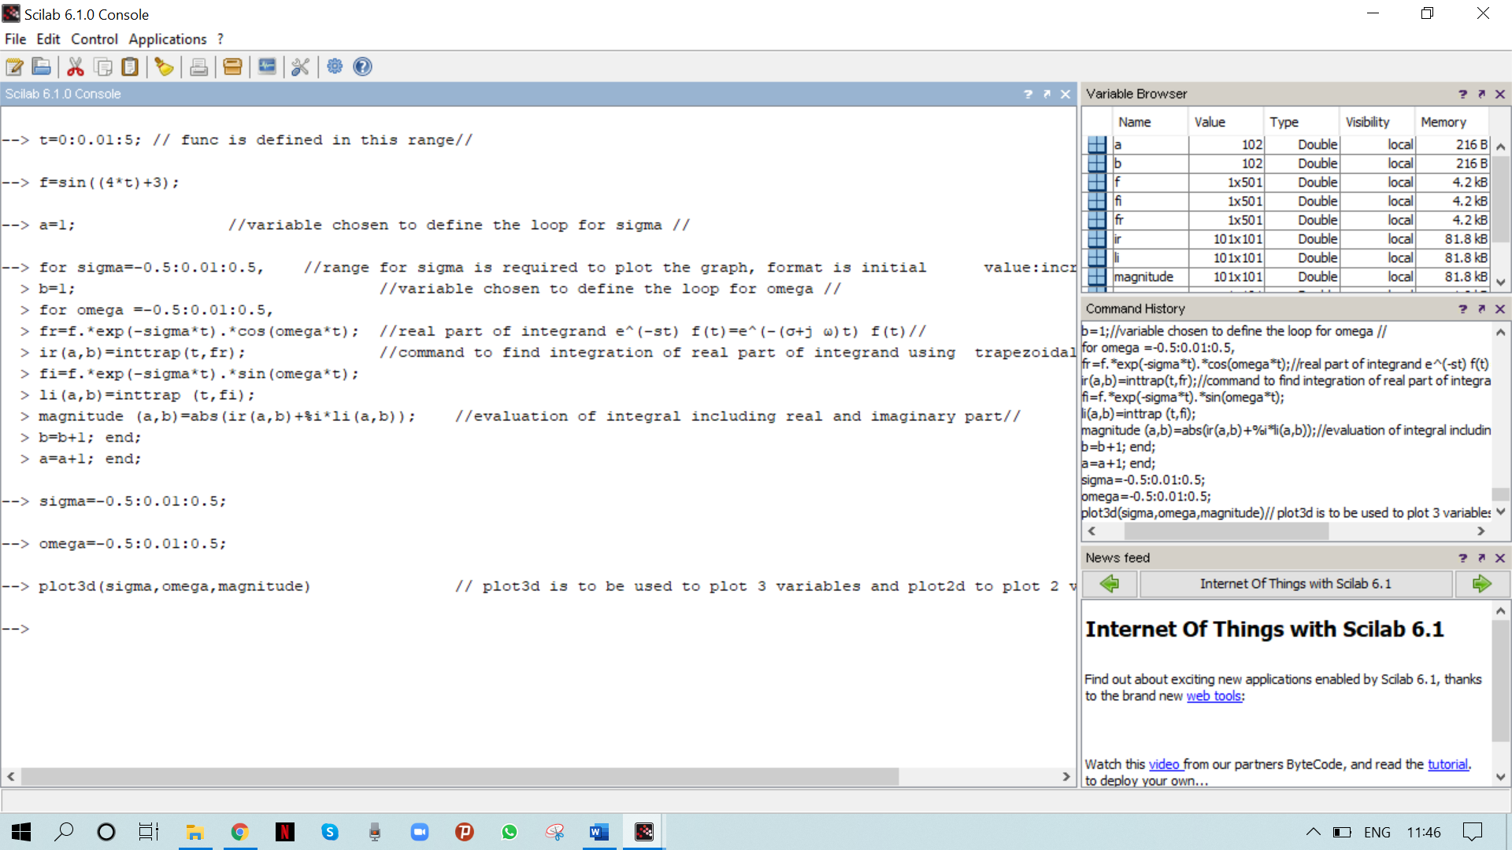

**Graphic window**

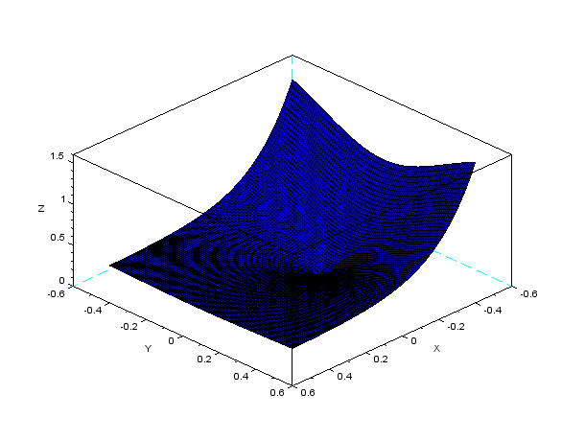

**Note: to paste the graph, click on copy to clipboard in file in graphic window and give the command paste here.**